

**Media release**

6 March 2023

**Trees lower temperatures in a Sydney street by 20 degrees**

* **New report outlines the health benefits of trees**
* **Doctors for the Environment Australia says trees can save lives**

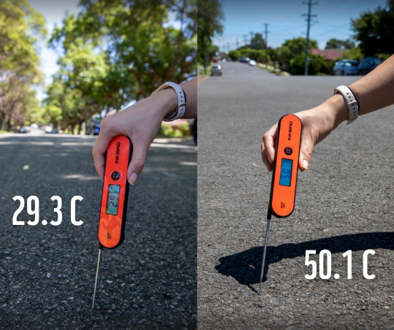 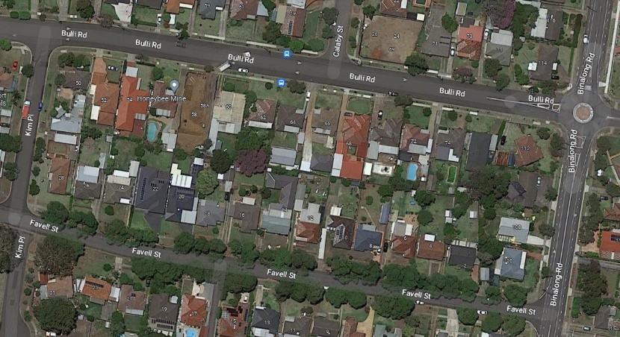

A [new report](https://aus01.safelinks.protection.outlook.com/?url=https%3A%2F%2Fwww.wwf.org.au%2Fknowledge-centre%2Fresource-library%2Fresources%2Ftrees-the-forgotten-heroes-for-our-health&data=05%7C01%7CPFahy%40wwf.org.au%7C0da3671748c942c35d7b08db1a18d86e%7C0b382bcb9e57439488d0ba19c162e669%7C0%7C0%7C638132466247867626%7CUnknown%7CTWFpbGZsb3d8eyJWIjoiMC4wLjAwMDAiLCJQIjoiV2luMzIiLCJBTiI6Ik1haWwiLCJXVCI6Mn0%3D%7C3000%7C%7C%7C&sdata=0ESSNpR7l415Fcclh%2FxG4Q4gW3bM4rVXrIUXyKy4%2FoU%3D&reserved=0) shines a spotlight on the health benefits of trees with protection against heat a significant factor in a nation which suffers heatwave conditions.

Trees lower surface and air temperatures by providing shade. Research has shown that shaded surfaces may be 11-25°C cooler than the peak temperatures of unshaded surfaces.

This was driven home recently on a hot day in Sydney’s west. In Toongabbie, two parallel streets are virtually identical except one is lined with trees.

On 16 February 2023 the surface temperature in the tree-lined street was 29.3 degrees Celsius while the unshadedstreet reached 50.1 degrees Celsius – a difference of more than 20 degrees.

“Heatwaves in Australia kill more people than all the other disasters combined. Trees are one of the ways that we can really reduce people's exposure to heat,” said Dr Cybele Dey from medical group Doctors for the Environment Australia (DEA).

“In streets with a tree canopy, temperatures are significantly lower. During heat waves people can suffer heart attacks, strokes, heat exhaustion, and complications with medication. This is happening at a much bigger scale than people realise,” Dr Dey said.

DEA and the World Wide Fund for Nature-Australia today released a joint report, [*Trees. The forgotten heroes for our health*](https://aus01.safelinks.protection.outlook.com/?url=https%3A%2F%2Fwww.wwf.org.au%2Fknowledge-centre%2Fresource-library%2Fresources%2Ftrees-the-forgotten-heroes-for-our-health&data=05%7C01%7CPFahy%40wwf.org.au%7C0da3671748c942c35d7b08db1a18d86e%7C0b382bcb9e57439488d0ba19c162e669%7C0%7C0%7C638132466248024290%7CUnknown%7CTWFpbGZsb3d8eyJWIjoiMC4wLjAwMDAiLCJQIjoiV2luMzIiLCJBTiI6Ik1haWwiLCJXVCI6Mn0%3D%7C3000%7C%7C%7C&sdata=XGawv73bT9vF7XPhbvwkFX239ZAmHUZMy%2FY9UNF0mqE%3D&reserved=0), highlighting research on how trees are essential to our health and very survival.

The report launches WWF’s [*‘We all need trees’*](https://aus01.safelinks.protection.outlook.com/?url=http%3A%2F%2Fwwf.org.au%2Fwe-all-need-trees&data=05%7C01%7CPFahy%40wwf.org.au%7C0da3671748c942c35d7b08db1a18d86e%7C0b382bcb9e57439488d0ba19c162e669%7C0%7C0%7C638132466248024290%7CUnknown%7CTWFpbGZsb3d8eyJWIjoiMC4wLjAwMDAiLCJQIjoiV2luMzIiLCJBTiI6Ik1haWwiLCJXVCI6Mn0%3D%7C3000%7C%7C%7C&sdata=2SlcNN8ZMriivO0lj6K9jl4LjKiNjVuUIM%2Bc3%2BqoqfE%3D&reserved=0)campaign drawing attention to the benefits of trees and the need for Australia to urgently transition from a deforestation hotspot to a world leader in reforestation.

Trees don’t just shield people from heat extremes through shade. Individual trees can transpire hundreds of litres of water per day which can significantly cool air temperatures.

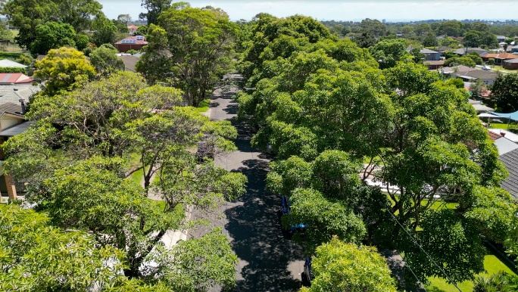  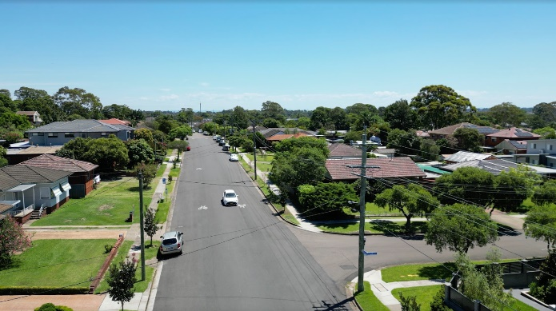

The surface temperature in the tree-lined street (left) in Toongabbie was more than 20 °C cooler than a parallel street with few trees (right)

Climate change is the biggest threat to human health. Each year, the Earth’s forests absorbaround a quarter of all the CO2 humans add to the atmosphere, mitigating climate change and thereby protecting people.

“Air pollution contributes to more than 3,000 deaths each year in Australia. Those figures would likely be higher without trees which help filter air pollution. They also help cleanse water so that we use fewer chemicals to make water drinkable,” said Dr Kim Loo from Doctors for the Environment Australia.

Research shows trees improve mental health.

“For people who are experiencing worry or stress, but who do not need professional help, spending time in nature is really beneficial,” said Dr Dey, a child and adolescent psychiatrist.

Dr Cybele Dey, Dr Stuart Blanch, and Dr Kim Loo have launched a joint DEA/WWF-Australia report on the health benefits of trees

Dr Stuart Blanch, a conservation scientist with WWF-Australia, spends his days saving existing forests and working to regenerate lost forests.

“Trees are world class multi taskers. They make oxygen, they make rain, they store carbon dioxide in our fight against climate change, they cool our suburbs, they improve our mental health. Every single Australian needs trees,” Dr Blanch said.

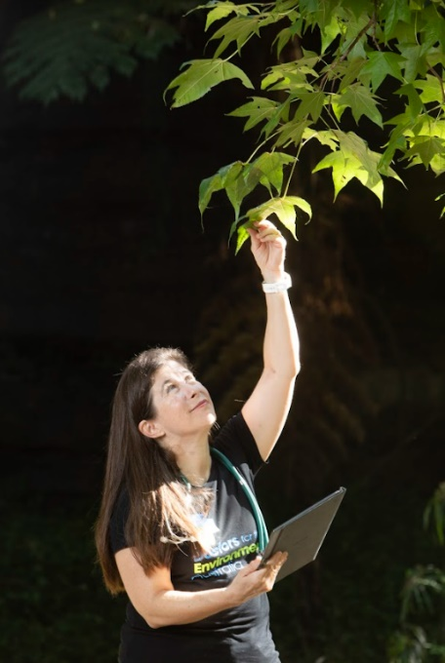   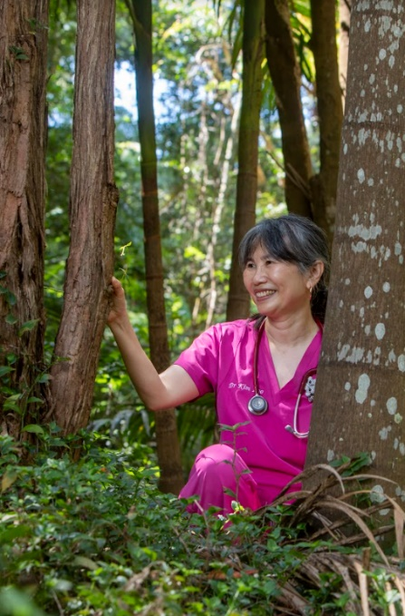

Dr Cybele Dey                                                                                                                             Dr Kim Loo

Trees give us food and medicine. Over a third of medicines come from nature and it’s estimated forests hold many potential treatments waiting to be discovered.

The shade from trees encourages exercise. One study showed street tree density increases both the likelihood of walking and the distances walked.

Tree climbing helps children develop strength and self-confidence.  However, less than 20% of children participate in tree climbing today, compared with 65% of adults who climbed trees during their childhood.

Trees are critical to the health and wellbeing of Traditional Owners providing connection to Country.

“Aboriginal and Torres Strait Islander people have been caring for Country for millennia. The wisdom and knowledge they have about caring for and protecting trees is actually something we can all be learning from,” said Dr Dey.

To download the *Trees. The forgotten heroes for our health* report go to [https://www.wwf.org.au/knowledge-centre/resource-library/resources/trees-the-forgotten-heroes-for-our-health](https://aus01.safelinks.protection.outlook.com/?url=https%3A%2F%2Fwww.wwf.org.au%2Fknowledge-centre%2Fresource-library%2Fresources%2Ftrees-the-forgotten-heroes-for-our-health&data=05%7C01%7CPFahy%40wwf.org.au%7C0da3671748c942c35d7b08db1a18d86e%7C0b382bcb9e57439488d0ba19c162e669%7C0%7C0%7C638132466248024290%7CUnknown%7CTWFpbGZsb3d8eyJWIjoiMC4wLjAwMDAiLCJQIjoiV2luMzIiLCJBTiI6Ik1haWwiLCJXVCI6Mn0%3D%7C3000%7C%7C%7C&sdata=XGawv73bT9vF7XPhbvwkFX239ZAmHUZMy%2FY9UNF0mqE%3D&reserved=0)

WWF is calling for Australia to become a world leader in reforestation and move away from native forest logging to plantations.

**About Regenerate Australia**

WWF’s Regenerate Australia is the largest and most innovative wildlife recovery and landscape regeneration program in Australia’s history. Launched by WWF-Australia in October 2020, the multi-year program will rehabilitate, repopulate and restore wildlife and habitats affected by the 2019-2020 bushfires, and help to future-proof Australia against the impacts of changing climate.

Find out more and help Regenerate Australia at  [www.wwf.org.au/regenerate-australia](https://aus01.safelinks.protection.outlook.com/?url=http%3A%2F%2Fwwf.org.au%2Fregenerate-australia&data=05%7C01%7CPFahy%40wwf.org.au%7C0da3671748c942c35d7b08db1a18d86e%7C0b382bcb9e57439488d0ba19c162e669%7C0%7C0%7C638132466248024290%7CUnknown%7CTWFpbGZsb3d8eyJWIjoiMC4wLjAwMDAiLCJQIjoiV2luMzIiLCJBTiI6Ik1haWwiLCJXVCI6Mn0%3D%7C3000%7C%7C%7C&sdata=ZAACH2qoGHIduthYu656k%2FQgoCv9xtDPz1xMjKn6boc%3D&reserved=0)

**Images:**

Here's a [link](https://dams.wwf.org.au/resourcespace/?c=5079&k=757add8f70) where media can download pictures.

Please credit © WWF-Aus / think Mammoth

**Media interviews: DEA doctors are available in NSW, Victoria, WA, NT**

Contact DEA Media Manager Carmela Ferraro, 04107 03074